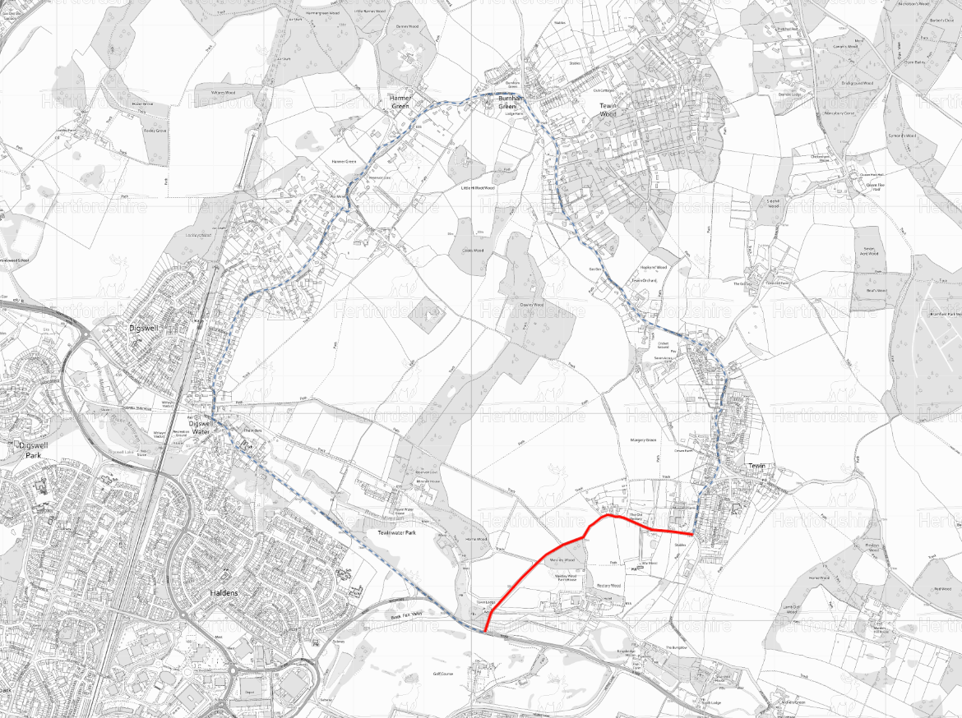

TEMPORARY TRAFFIC REGULATION ORDER

CWY240321-a Churchfield Road

Ferryhills Close

North

Closure &
Waiting Restrictions

Diversion

C49 Harmer Green Lane

C50 Orchard Road

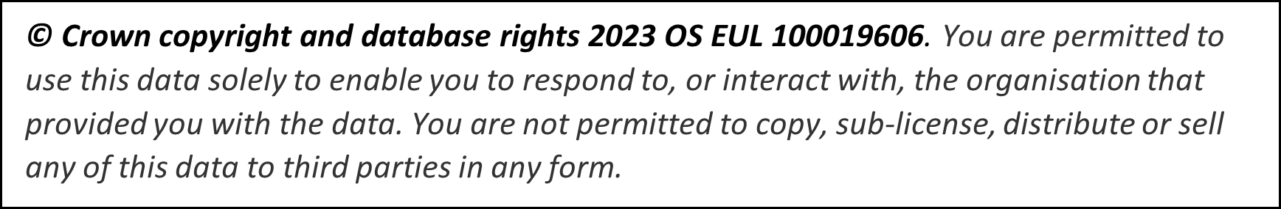

C182 Hertford Road
B1000 Hertford Road
C50 Upper Green Road
C49 Harmer Green Lane
C49 New Road
C50 Upper Green
C50 Lower Green
C50 School Lane
C148 Churchfield Road

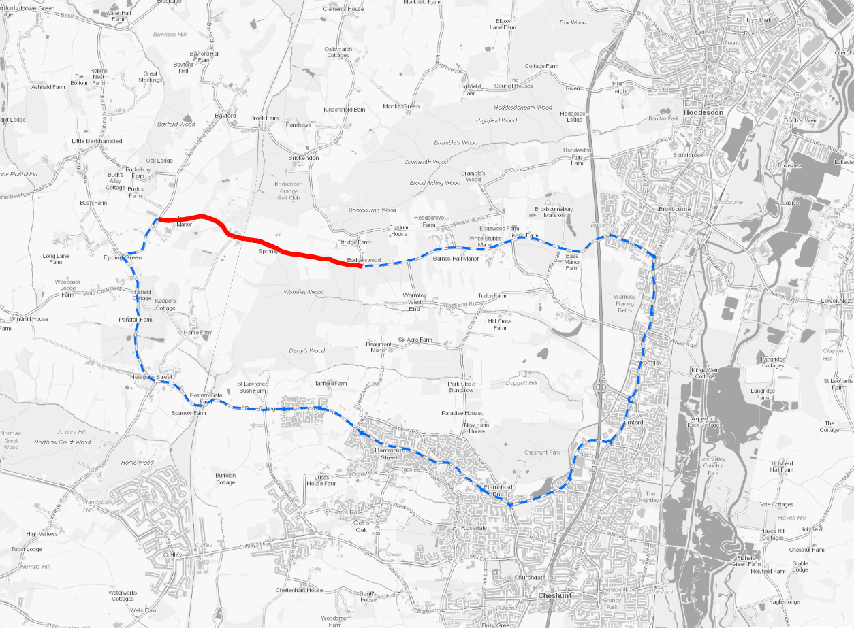

TEMPORARY TRAFFIC REGULATION ORDER

CWY240323-a White Stubbs Lane

Ferryhills Close

Road Closure &
Waiting Restrictions

Diversion

North

C54 between Tylers Causeway and East Herts District boundary
C54 Newgate Street Village
C54 Newgate Street
C54 Darnicle Hill
C54 Hammondstreet Road
C54 Dig Dag Hill
C54 Longfield Lane
B156 Brookfield Lane West
B156 Halfhide Lane
A10 Great Cambridge Road
A1170 High Road
Baas Hill
C56 White Stubbs Lane

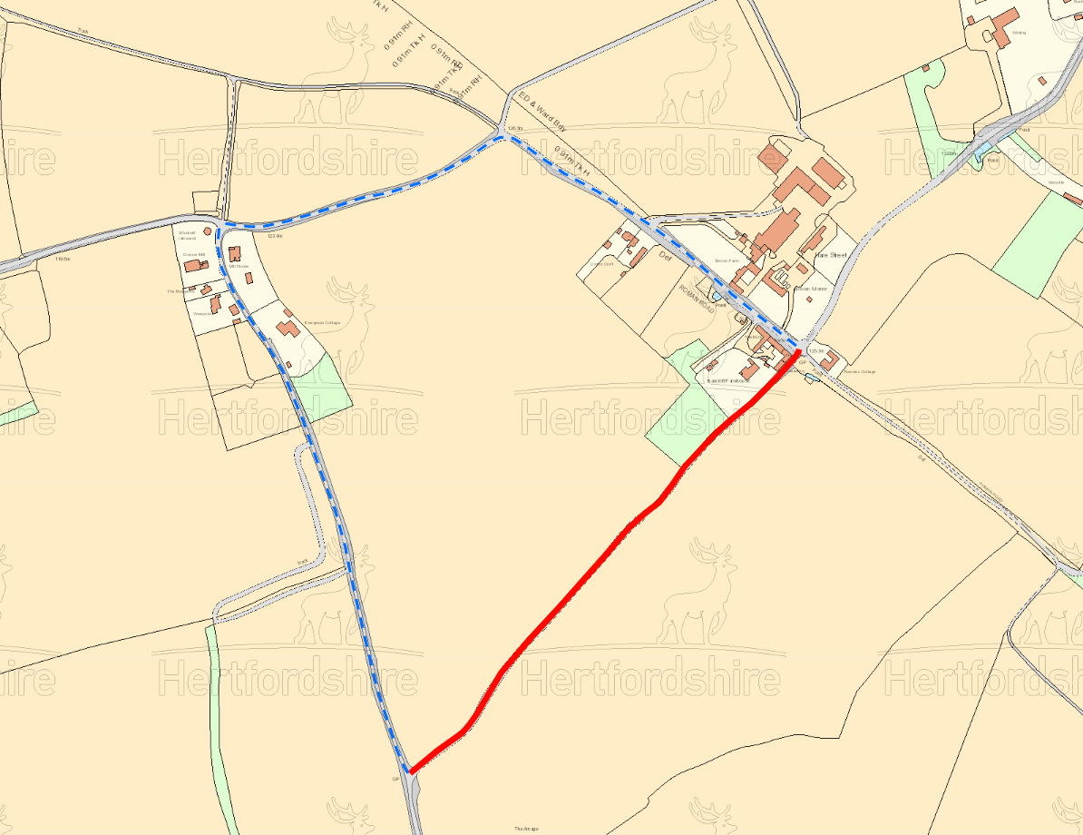

TEMPORARY TRAFFIC REGULATION ORDER

CWY240226-a Blind Lane

Ferryhills Close

Road Closure &
Waiting Restrictions

Diversion

North
B1037 from Hare Street to White Hill

Mill Lane
Blind Lane

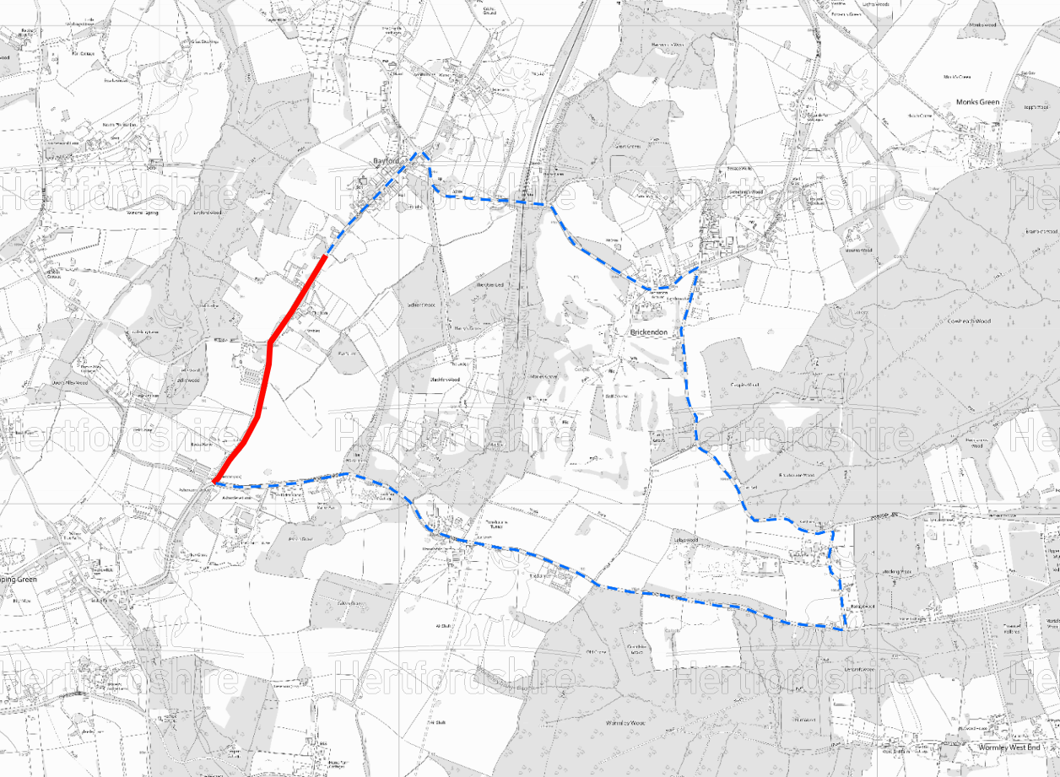

TEMPORARY TRAFFIC REGULATION ORDER

CWY240217-a Ashendene Road

Ferryhills Close

Road Closure &
Waiting Restrictions

Diversion

North

Bayford Road

Brickendon Green
White Stubbs Lane
Pembridge Lane
Ashendene Road

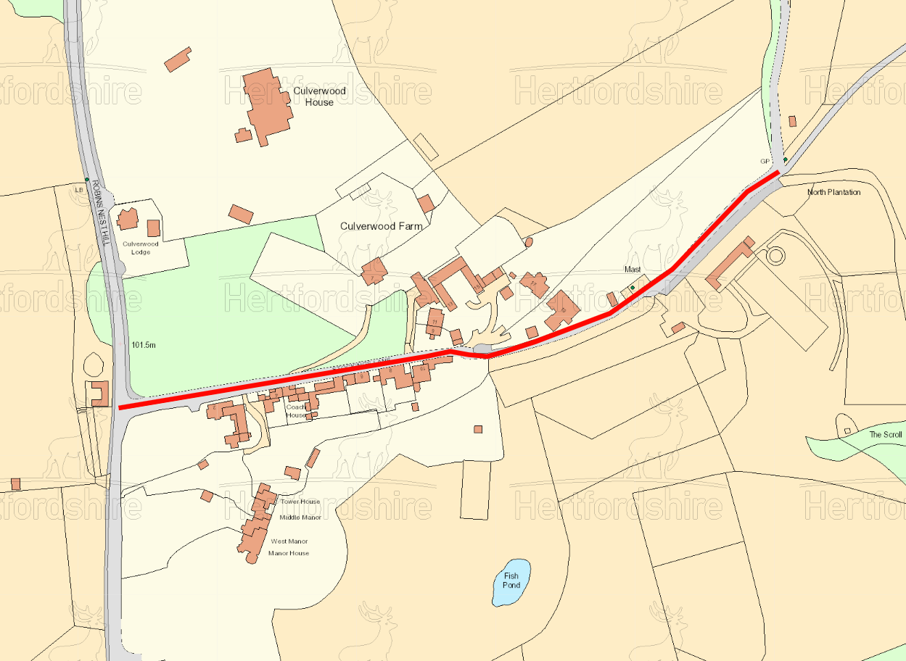

TEMPORARY TRAFFIC REGULATION ORDER

CWY240216-a Stockings Lane

Ferryhills Close

Road Closure &
Waiting Restrictions

North

Stockings Lane

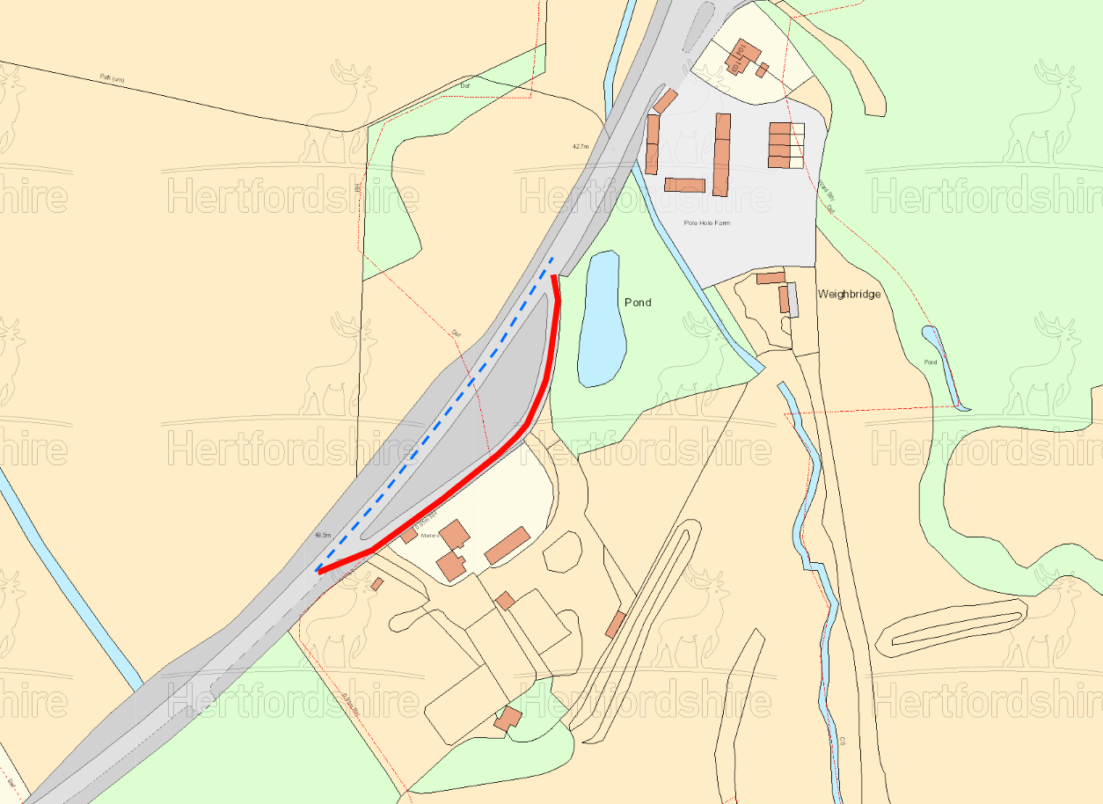

TEMPORARY TRAFFIC REGULATION ORDER

CWY240224-a Classified Road C161

Ferryhills Close

Road Closure &
Waiting Restrictions

Diversion

North

C161 Pye Corner
Classified Road C161

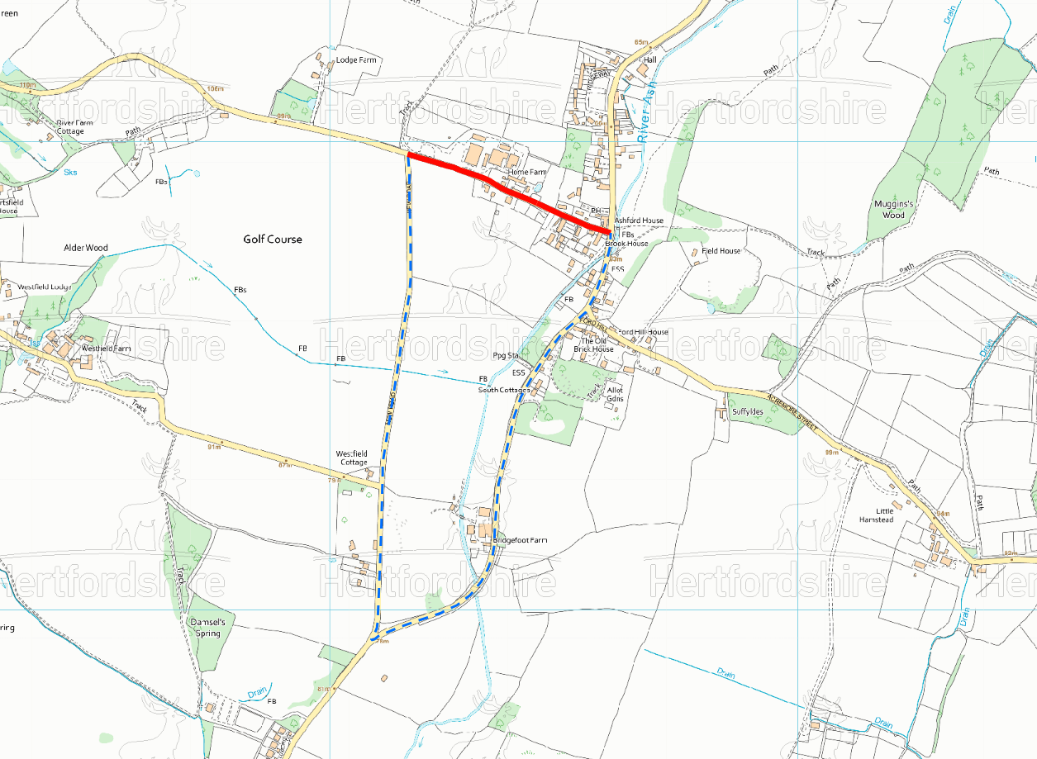

TEMPORARY TRAFFIC REGULATION ORDER

CWY240219-a Chapel Lane

Ferryhills Close

Road Closure &
Waiting Restrictions

Diversion

North

Chapel Lane

New Road
The Ford

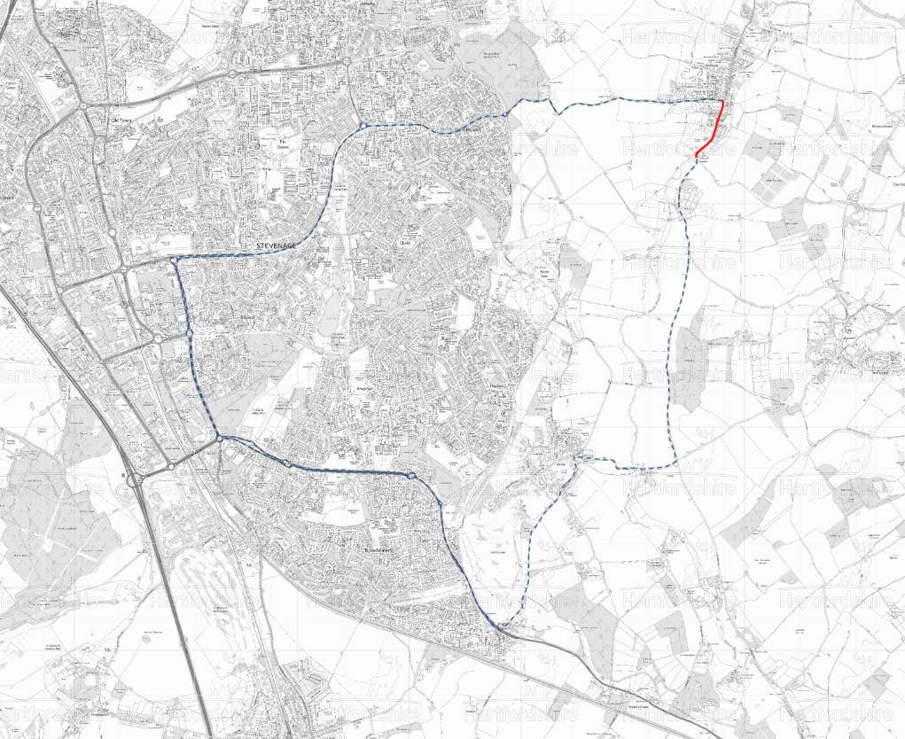

TEMPORARY TRAFFIC REGULATION ORDER

CWY240313-a High Street

Ferryhills Close

North

Closure &
Waiting Restrictions

Diversion
B1037 Stevenage Road

B1037 Fairlands Way

C30 High Street

A1188 Fairlands Way

C30 Benington Road
A1155 St Georges Way
A602 Monkswood Way
A602 Broadhall Way
C29 Aston Lane
C29 Benington Road
C30 Walkern Road

