Ask your Parish or Town Council to vote for 20mph
20’s Plenty for Us is asking Parish and Town Councils in Hertfordshire to pass a motion to support the campaign for 20mph where people live, work and play. Each local council that does will help:
- Achieve a 20mph speed limit on roads, with exceptions where 30mph is demonstrably safe, particularly for vulnerable road users.
- Demonstrate to the Highways Authority the demand for 20mph county-wide, making it both cheaper and easier to implement across the county and achieving better driver compliance.
Speed limits are set by Hertfordshire as the Highway Authority, which also makes Traffic Regulation Orders to erect signs or change other road features like paint roundels or remove centre lines. Demonstrating widespread local community support is critical to securing the County’s agreement to implement 20mph widely. Other counties, such as Lancashire and Sefton in England, have agreed 20mph for every settlement, as have counties throughout Wales. Scotland has promised to offer 20mph widely and places like Warrington have 20mph in all their satellite villages.

Motion
Walkern Parish Council
- Supports the 20’s Plenty for Hertfordshires campaign;
- Calls on Hertfordshire County Council to implement 20mph in Walkern; and
- Will write to Hertfordshire County Council to request 20mph speed limits on streets throughout Hertfordshire where people live, work, shop, play or learn, with 30mph as the exception on those roads, where full consideration of the needs of vulnerable road users allows a higher limit.
- Please contact Walkern Parish Council if you would like this scheme to be adopted in Walkern

Background information on 20mph speed limits
- Accepted as normal by local authorities where 25m people in the UK live, including the whole of Wales and (soon) Scotland. 20mph is global best practice where people mix with motor traffic.
- Popular: Government and other surveys consistently find 70% support in residential streets which rises after 20mph limits are introduced.
- Affordable and cost effective, with multiple societal, environmental, economic, and climate benefits.
- Prioritise quality of life: 20mph helps to create places where human activity, including walking, cycling and social interaction, takes precedence over traffic.
- Safer: The UK’s Department for Transport estimates that speed a reduction of 1mph in built-up areas reduces casualties by 6%. 20mph schemes typically lead to up to 20% fewer casualties.
- Better for the environment: 20mph reduces CO2 emissions by 26% and NOx by 28% compared with 30mph and is 50% quieter.
- Enforceable, like any speed limit.
- Little impact on journey times: The ‘stop-start’ nature of traffic in built up areas is a much more significant factor. Roads can stay at 30mph where the needs of vulnerable road users are met. Bus journeys and timetables times are generally unaffected.
- Speed reductions occur, even without regular Police enforcement, to the benefit of all road users. Note: all new car models will have in-car speed limiters from 2022.
- Few signs needed: 1 or 2 signs on entry and some repeaters to remind drivers and no need for physical calming.
- Sustainable: Ties in closely with other policies to address climate change, improve air quality and enable more people to walk and cycle – especially for short journeys.

Signed schemes and public engagement are cost-effective and offer seven times better value for money than heavily-engineered schemes.

More on Benefits of Wide Area 20mph
- Wide area 20mph is 7x more cost effective
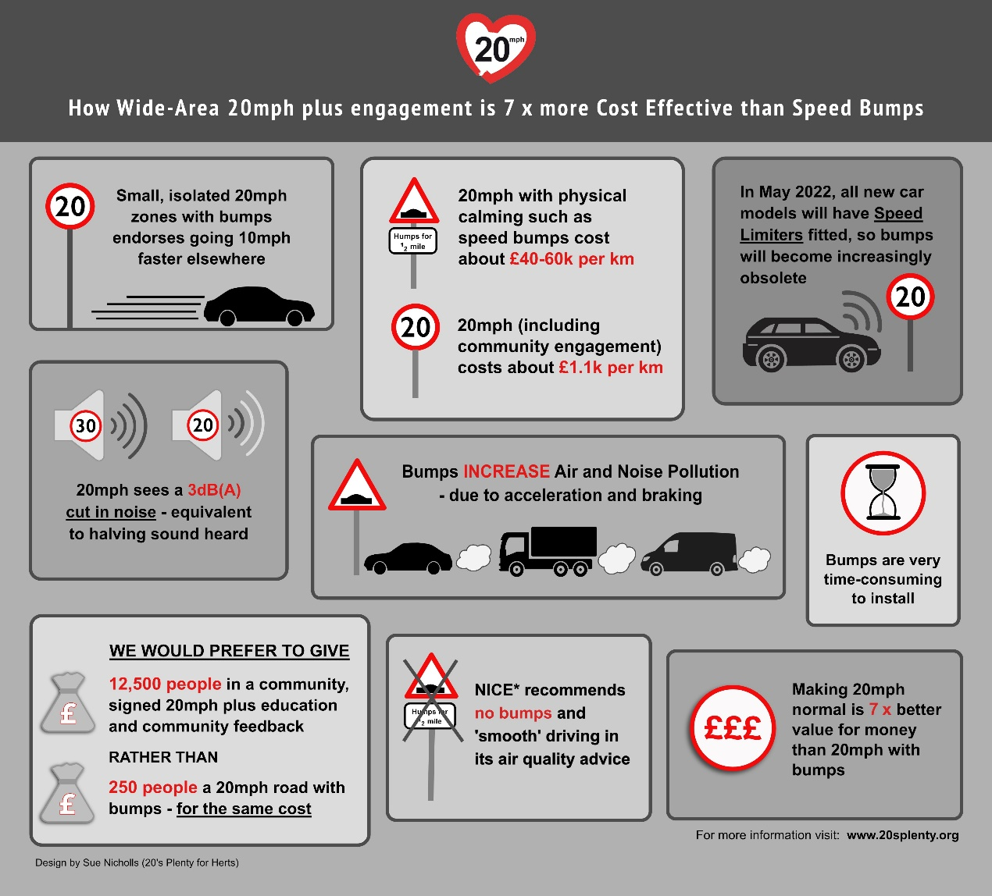
- Safer streets for all, particularly children and the elderly
Significantly reduced risk of serious injury, especially for vulnerable road users together with less fear and intimidation from motor vehicles. Children under 14 years old cannot correctly judge traffic speeds and adults have to keep them safe by setting speed limits and driving at speeds that reduce danger. Being hit at 20mph is around 7x less serious than being hit at 30mph. It’s like falling from the 1st floor rather than the 3rd floor of a building.
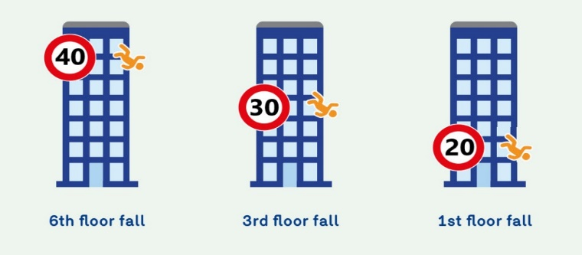
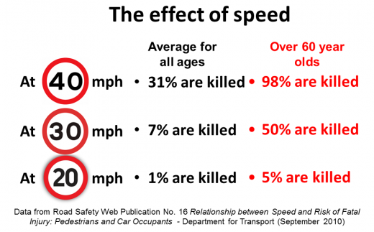

- More time to see…
At 20mph your range of vision is greater, enabling you to anticipate danger better.
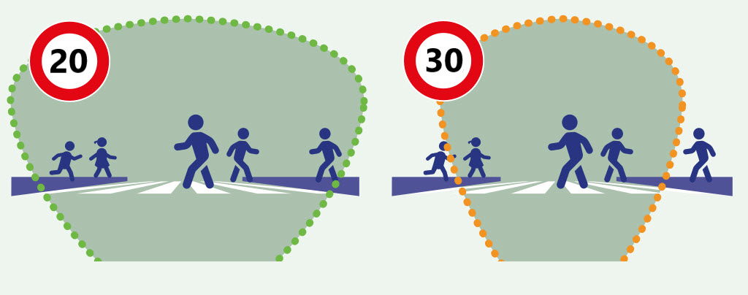
- …and more time to stop
Not only do you see danger earlier, you can stop more quickly. At the point that a car going at 20mph has stopped, a car at 30mph is still travelling at 24mph.
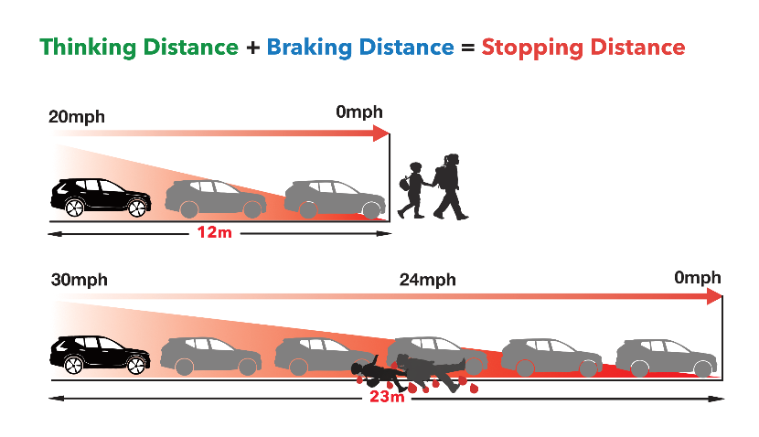
- Promoting healthy lifestyle: better public health, less pollution, better community
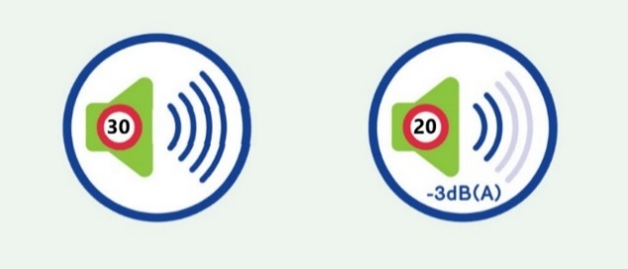
Inactivity and pollution are major causes of early death in
the UK and 20mph is associated with higher levels of activity.
As well as reducing obesity, heart disease and loneliness, increased walking and cycling reduces pollution, improves sleep patterns (vehicles at 20mph emit 50% less noise than at 30mph), makes people less anxious and more sociable. The elderly and vulnerable retain independent mobility longer, keeping them self-sustaining in daily life which reduces social care costs. Children can play out and learn independent mobility, with less taxi duty for parents and carers. Finally, 20mph enables lifestyle changes, renewed community life and a positive atmosphere. Our towns and villages will be more attractive, liveable and sustainable places.
- Enforcement
- As with any speed limits, 20mph is enforceable. Individual police forces choose to place different priorities on speed management. Some, such as Avon and Somerset and Metropolitan Police are very active; others less so.
- Even without regular enforcement 20mph limits reduce speeds, collisions and casualties, particularly where there is driver education through community engagement, such as Community Speedwatch.
- Compliance will increase over time, as drivers become used to 20mph. Compliant drivers effectively become pacer vehicles to enforce 20mph on the traffic behind them.
- The introduction of “in car speed limiters” – likely to be mandatory on new models from 2022 and all vehicles from 2024 – will further increase compliance without external enforcement. Although drivers can choose to override the limiter, most will welcome the reassurance that they are not breaking the law inadvertently. Vehicles will also have black boxes fitted, which can record the speed limit in the event of a collision, affecting a driver’s liability.
- Strengthening the local economy
20mph aids local business as people want to shop, socialise and live in 20mph places. Helps fight the trend to online buying towards the local economy and, in particular, our local high streets and town centres.
- Lowering the cost of traffic danger
Road casualties are responsible for the loss of over 2% of GDP. Collisions are predictable and preventable. Introducing a safer system by reducing speed brings down casualties, saves money as well as pain and suffering. The trend towards 20mph is well-established in the UK and other countries. With 20mph coming, don’t let where you live be left behind.
Wide area 20mph limit schemes typically cost no more than £5-6 per head. Where several places are made 20mph, together some costs, such as the Traffic Regulation Order, can be shared. Larger areas tend to be cheaper per person, since they required fewer signs.
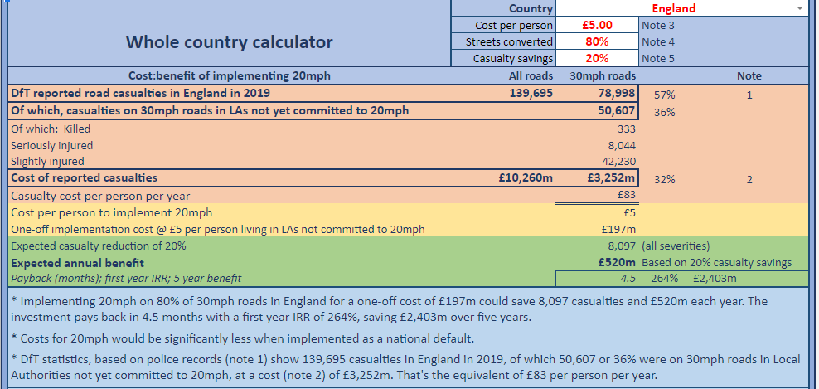
20mph is not expensive and the investment cost brings benefits for years; typically it pays back within months. A calculator on the 20’s Plenty website – see example below – can show the cost benefit for your Highway Authority: https://www.20splenty.org/cost_benefit_calculator.
- Signed only limits reduce road speeds
Road safety is improved even without 100% compliance with a 20mph limit. Studies, such as those below show that reductions in average seeds are achieved without physical traffic calming or enforcement and such reductions are greatest on faster roads. Even relatively small changes in average speed result in significant casualty savings.
Over time, as 20mph limits become more established and in-car speed limiters become more widespread, compliance levels will increase and average speeds reduce further.
CASE STUDY - Bristol
Much of Bristol is now 20 mph. Studies have found that speeds on 94% of surveyed roads had fallen, with an overall 2.7mph reduction in average speeds offering estimated casualty reductions per year of 4.53 fatalities, 11.3 serious injuries and 159.3 slight injuries.
These total an estimated cost saving of over £15 million per year - annual savings over 5 times greater than the one-off roll-out cost of £2.77m mostly funded by Government. Over a ten-year period, 20mph in Bristol will have saved 45 lives, 113 serious injuries, 1,593 minor injuries, and save over £147m net - a fantastic return on a public health investment! It also saves drivers on average £50 per vehicle per year on fuel.
CASE STUDY - Scottish Borders
In a trial involving over 100 communities in the Scottish Borders, speeds were shown to reduce by an average of 3mph, with greater reductions in places with higher pre-speeds.
As well as lowering speeds overall, the number of places with higher speeds also reduced. Before the scheme, locations experiencing average speeds above 28mph fell from over 40 to NONE after implementation.
CASE STUDY - Faversham
In this historic market town of 20,000 people in Kent, 20’s Plenty for Faversham successfully campaigned for a town-wide 20mph limit, which went live in September 2020. As well as being popular, speeds reduced by 4 – 5 mph on the faster roads.
Initially opposed by Kent County Council, strength of local support and the technical design showed that it would be more cost-effective to implement a town-wide 20mph speed limit.
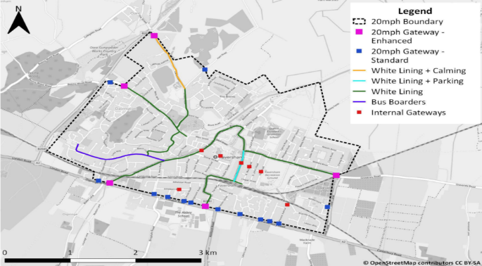
Low-cost techniques to reduce traffic speeds were accepted by the highway authority: attractive gateways to the settlement announcing the speed limit change and resident-led ‘Community Corners’, - as planters at key locations.

